V5 LOGISTICS AND WAREHOUSING
Daily Demand Planning and Vehicle Allocation Optimization at V5 Logistics and Warehousing
Improving Shipment Visibility, Coordination, Data Accuracy, and Transportation Execution Through a Centralized Excel-Based Tracking System

Item | Detail
Prepared by | Mahir Valani, Intern, V5 Logistics and Warehousing
Report type | PGDM internship project report
Focus | Daily demand planning, vehicle allocation, shipment coordination and shipment data accuracy

Contents
1 Cover Page
2 Executive Summary
3 Company and Operational Context
4 Project Background
5 Problem Statement and Objectives
6 Scope of Work and My Role
7 Existing Logistics Process
8 Daily Demand Planning and Vehicle Allocation
9 Operational Challenges and Root-Cause Analysis
10 Centralized Excel Tracking Dashboard
11 Shipment Data Accuracy Improvement
12 Reported Cycle-Time Improvement
13 KPI Framework and Performance Measurement
14 Recommended Future-State Operating Model
15 Financial and Commercial Implications
16 Implementation Roadmap
17 Risks, Limitations and Management Considerations
18 Key Findings and Conclusion
19 Appendices

2 Executive Summary
V5 Logistics and Warehousing coordinates transportation of ATM machines through primary, secondary and last-mile stages, handling approximately 150+ consignments daily. Before a shared tracker was introduced, shipment information sat across email, WhatsApp, phone calls and individual follow-ups, and there was no deployed ERP giving the team a single operational view.
The team created a shared, cloud-based Excel tracking dashboard to centralise consignment-level information. As part of a team of about four to five, with a second intern, I supported secondary transportation and vendor coordination and contributed to using the tracker. Team experience indicated an estimated 10% relative improvement in shipment data accuracy, and the operational cycle was reported to fall from about 10 days to 4–5 days (50–60%).
150+  Daily consignments  Team operation, all three stages | ≈3,900  Consignments per month  150 × 26 operating days (illustrative scale)
≈10%  Estimated data-accuracy gain  Relative improvement, team experience | 50–60%  Reported cycle-time reduction  ≈10 days to ≈4–5 days

Decision-oriented findings
- Visibility was the core constraint. Coordination quality depended on retrieving the latest status from scattered conversations. A shared record gives one reference for Tier 1 Meeting / Daily Huddle and S&OE reviews.
- A vehicle being available is not the same as a shipment being ready. Site readiness, authorised receiver availability, bank holidays and special unloading needs decide whether a dispatch converts into a delivery.
- Excel is a practical bridge, not an ERP. Its value depends on mandatory fields, standard statuses, clear ownership and periodic data-quality checks.
- Recommended next steps: standardise fields and IDs, add required-field and readiness controls, measure KPIs from actual records, and evaluate ERP/TMS needs only with a clear business case.
The 10% accuracy improvement and the cycle-time reduction are separate, reported estimates. No financial saving is claimed.

3 Company and Operational Context
V5 Logistics and Warehousing is a third-party logistics (3PL) provider in Maharashtra, coordinating transportation and delivery of ATM machines. The Bhiwandi hub plays an important role in the Maharashtra distribution network. Daily work includes receiving customer requirements by email, consolidating demand across locations, coordinating vendors, planning transportation, allocating vehicles, checking delivery readiness, tracking consignments and resolving exceptions.
Stage | Movement
Primary transportation | From the originating location to the designated warehouse or operational hub
Secondary transportation | From the warehouse or hub to district-level vendors or distribution points
Last-mile delivery | Final transportation to the bank branch, ATM installation location or customer site
Not every consignment follows every stage.

4 Project Background
The operations team consisted of approximately four to five members, with two interns supporting coordination alongside the broader team. Work was shared and team members assisted one another. The project focus emerged from daily operations: reducing the effort and risk involved in establishing the current status of each consignment, and improving the planning discipline behind vehicle allocation.

5 Problem Statement and Objectives
Multiple shipments, destinations, vendors, vehicles and delivery requirements were being coordinated through fragmented information channels. The team worked effectively within these constraints, but the structure made consistent records, early detection of missing information and retrieval of earlier conversations harder than necessary.
Problem dimension | Effect on operations
Fragmented shipment information | No single reference for the latest consignment details
Inconsistent or delayed status updates | Extra follow-up to establish current status
Difficulty identifying incomplete records | Missing information discovered late
Dependencies between primary, secondary and last-mile | A delay or information gap at one stage can affect the next
Vehicle allocation and consolidation | Compatible orders harder to see together
Site readiness and authorised receiver confirmation | Delivery attempts may be held or delayed
Exceptions and additional handling | Follow-up and ownership less visible
Limited historical visibility | Weaker basis for review and decisions

Objectives: (1) support daily demand planning and vehicle allocation; (2) improve shipment visibility and coordination across stages; (3) improve the consistency and accuracy of shipment records through a shared tracker; (4) establish controls and KPIs that make performance measurable.

6 Scope of Work and My Role
My responsibilities were collaborative. I supported transportation operations, particularly secondary transportation and vendor coordination, while participating in activities across the wider movement and delivery cycle. Final dispatch and commercial decisions rested with the team and management.

A Daily demand planning and shipment coordination
- Reviewed incoming shipment requirements and distribution instructions.
- Supported coordination of demand across destinations and organised consignment information for planning.
- Coordinated with vendors and team members regarding shipment movement.
- Supported alignment of requirements with vehicle availability and delivery schedules.
- Assisted in tracking status and identifying exceptions.
Illustrative example (not a historical order)
An email asks for 20 ATM machines to be distributed to 10 stations. The team would list the 10 stations, group them by district or compatible route, check each station's quantity and delivery date, confirm vendors and site readiness, and then agree vehicle movements. The number of vehicles follows from route compatibility, capacity and deadlines. No capacity figure is assumed.

B Vehicle allocation and load utilization
Compatible orders can be consolidated to improve vehicle utilisation and reduce avoidable transportation cost. I supported planning by grouping shipments by destination or compatible route, matching quantities to vehicle capacity, coordinating dispatch timing, and weighing utilisation against delivery deadlines and site readiness. The aim is to reduce inefficient partial loads where consolidation is feasible, without delaying urgent consignments.

C Vendor and delivery coordination
Vendor coordination turns a plan into a completed delivery. It covers vendor availability and dispatch confirmation, delivery-slot coordination, site readiness checks, confirmation of an authorised bank representative, special unloading arrangements and status follow-up. A vehicle being available does not mean the shipment is ready: if the site is closed, the receiver is absent or lifting arrangements are missing, a dispatched vehicle may wait or return.

D Daily operational reviews
Meeting | Contribution
Tier 1 Meeting / Daily Huddle | Short alignment on the day's shipments, open items, bottlenecks and immediate actions
S&OE (Sales and Operations Execution) | Execution-focused review of shipment status, delays and exceptions; coordination of next actions

7 Existing Logistics Process
Figure 1. SIPOC: daily shipment planning and execution
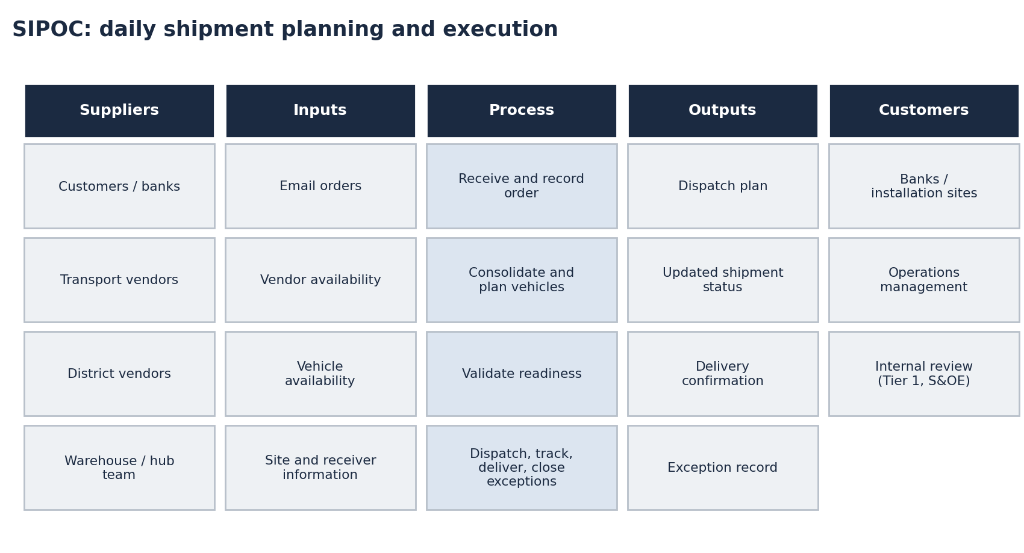
Source: operational account; process map by analyst.
A consignment could pass through primary transportation, warehouse handling, secondary transportation and last-mile delivery. Delays or information gaps at one stage could affect subsequent stages, which is why consistent shared information matters more than isolated vehicle assignment.

8 Daily Demand Planning and Vehicle Allocation
Planning step | What is checked
Group shipments | Destination or compatible route; schedule
Match quantity to vehicle | Shipment quantities against available vehicle capacity (figures not assumed)
Coordinate dispatch timing | Vendor availability; delivery date; sequencing
Check readiness | Site, authorised receiver, bank holidays, special unloading
Balance utilisation and deadlines | Consolidate only where it does not endanger urgent or unready deliveries
Utilisation is a means, not an end. Combining compatible orders reduces avoidable trips, but an urgent consignment waiting for a partner load, or a load dispatched to an unready site, can cost more than the consolidation saves.

9 Operational Challenges and Root-Cause Analysis
The observations below describe the operating conditions, not incident counts. Holding charges applied to some consignments only, and exact historical amounts are not available.
Operational issue | Underlying process weakness | Operational consequence | Immediate control | Long-term improvement
Information across email, WhatsApp, calls, individual follow-ups | No single shared record or required fields | Essential updates can be missed; latest status needs follow-up | Enter key facts from chats in the tracker the same day | Standard fields, mandatory validation, named owner per record
Bank holidays not communicated in advance | No holiday/closure check before dispatch | Delivery attempt on a closed day; possible holding | Check closures before dispatch | Maintained delivery calendar
Location not ready; authorised representative unavailable | Readiness is not a fixed pre-dispatch gate | Vehicle waits; delay; holding charge on some consignments | Confirm site and receiver before dispatch | Readiness fields required before 'Dispatched' status
Special unloading (e.g. upper floors in malls or commercial buildings) | Needs not captured at order intake | Delivery complicated; unplanned arrangements | Ask about unloading needs when order is received | Special-unloading field with arrangement confirmation
Multiple stages (primary, warehouse, secondary, last-mile) | Information gaps between stages | Delay at one stage affects later stages | Record stage and handover updates | One consignment ID tracked across stages
Machine damage and other exceptions | Exceptions not recorded consistently | Extra coordination; unclear follow-up ownership | Log with owner and reason | Exception reasons list; review at S&OE
Issues are operational observations. Immediate controls and long-term improvements are recommendations unless they match practices the team already used (shared tracker, Tier 1 / S&OE reviews). No incident counts, losses or damage rates are claimed.

10 Centralized Excel Tracking Dashboard
Because no ERP was properly deployed, the team created a shared, cloud-based Excel dashboard to centralise shipment information. It is a practical process improvement: it reduces reliance on fragmented conversations as the only source of shipment information and gives the team a shared record. It does not replace an integrated ERP and does not automate workflows.

Purpose
- Centralise consignment-level information and improve visibility across stages.
- Keep records more consistent and accessible to relevant team members.
- Help identify missing or incomplete information.
- Improve coordination with transportation vendors.
- Provide an organised basis for daily reviews, with better traceability of status and exceptions.
Figure 2. Before and after: information flow
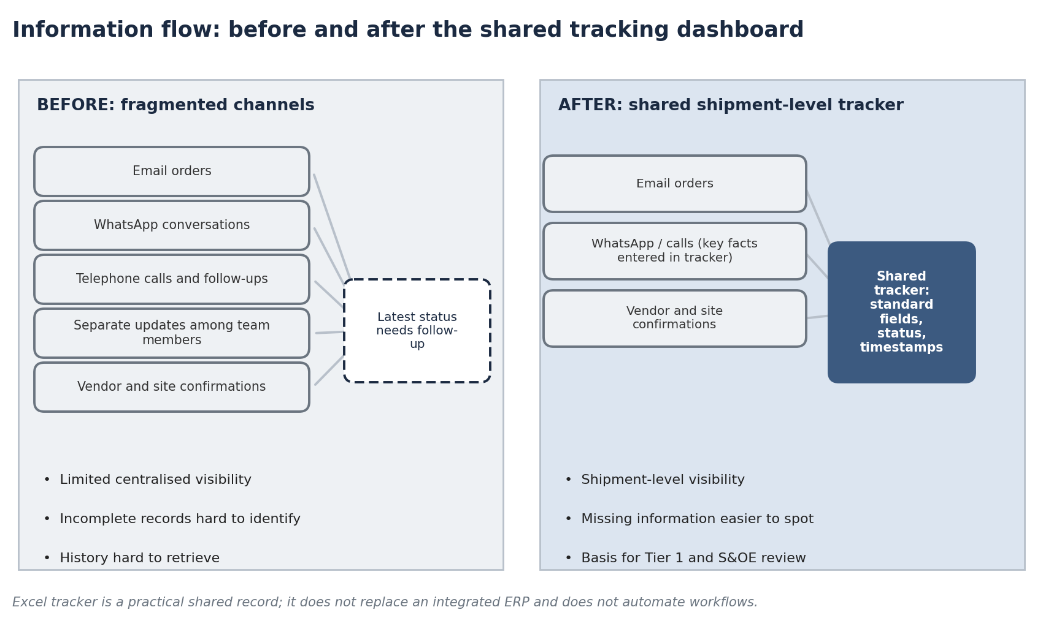
Source: operational account; schematic by analyst.

Recommended dashboard structure
The fields below are a recommended structure. The exact fields in the original dashboard are not documented in the project materials, so not every field is claimed to have been present. The accompanying workbook implements this structure.
Group | Fields
Identification | Consignment ID; order received date; customer or bank
Destination and quantity | Destination and delivery location; number of machines
Movement | Transportation stage; originating warehouse or hub; assigned vendor; vehicle identification
Dates | Planned dispatch; actual dispatch; required delivery; actual delivery
Status and readiness | Current status; site readiness; authorised receiver confirmation; special unloading requirement
Exceptions and control | Exception or delay reason; latest update timestamp; responsible team member; record completeness status; record correctness status

Governance recommendations
- Mandatory consignment IDs and a common ID structure.
- Standard status dropdowns and required-field validation.
- A named person responsible for updating each record.
- Update timestamps on every change.
- Defined access permissions.
- Periodic data-quality checks.
- A consistent rule that information received by WhatsApp or phone is entered in the tracker, so essential information does not remain only in conversations.

11 Shipment Data Accuracy Improvement
Team experience indicated an approximate 10% relative improvement in shipment data accuracy after the shared tracker was introduced. This is an estimated operational improvement. No formal historical audit was conducted.
Definitions
Shipment data accuracy (%) = accurate shipment records ÷ total shipment records audited × 100.
An accurate record has all required information (completeness) and values that agree with the source order, vendor confirmation or delivery evidence (correctness). The two are tracked separately.

Mechanism
The improvement is attributed to centralised information, more consistent record maintenance, visible updates, better detection of missing information, reduced dependence on fragmented communication and easier cross-checking of details.

Illustrating the calculation
Metric | Before dashboard | After dashboard
Records reviewed (illustrative) | 1,000 | 1,000
Records meeting accuracy criteria | 900 | 990
Records failing criteria | 100 | 10
Shipment data accuracy | 90% | 99%
Illustrative example to explain the calculation; not an actual company audit.
Figure 3. Illustrative audit calculation
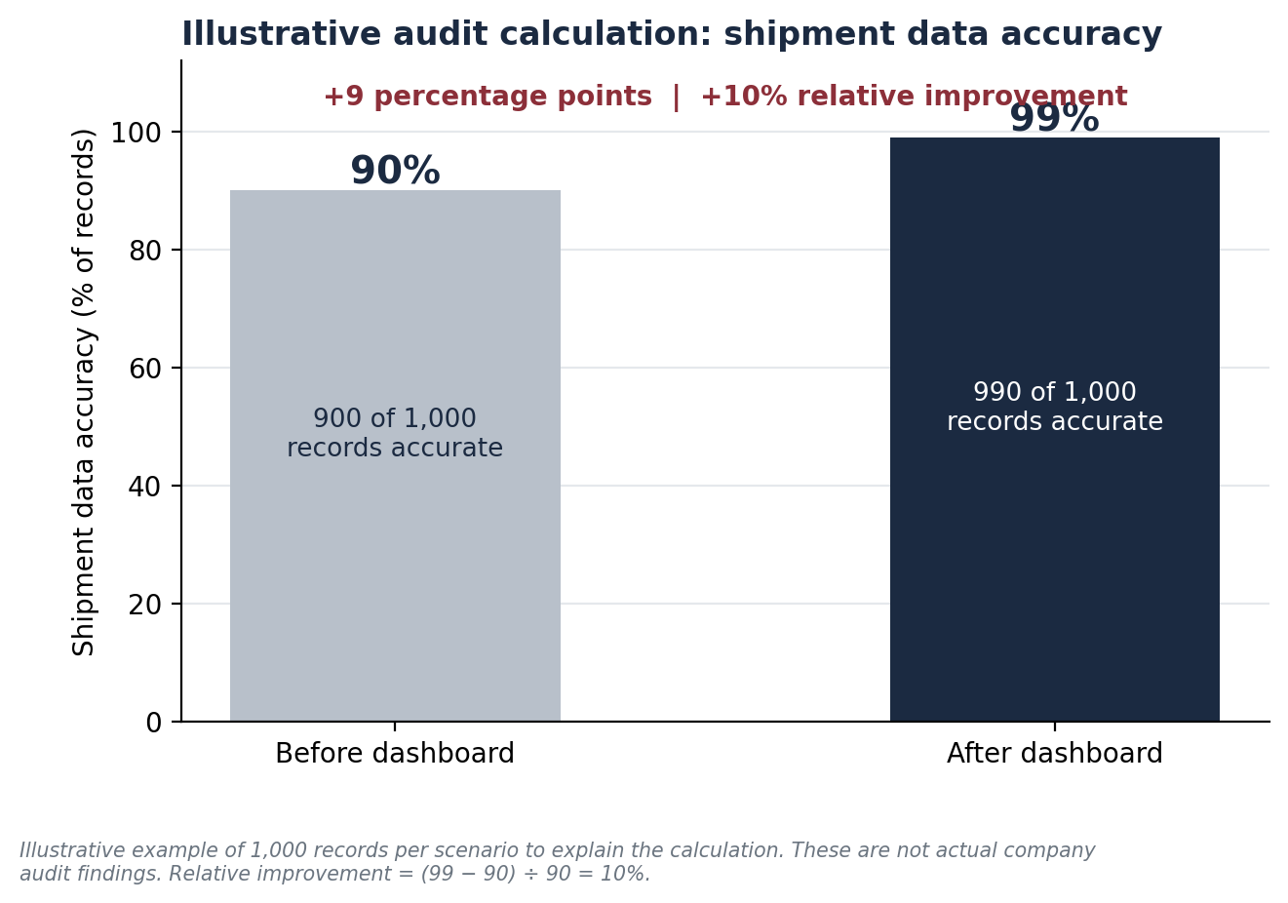
Calculation | Result
Before: 900 ÷ 1,000 × 100 | 90%
After: 990 ÷ 1,000 × 100 | 99%
Absolute change: 99% − 90% | 9 percentage points
Relative improvement: (99% − 90%) ÷ 90% | 10%
The estimated 10% is a relative improvement, not a 10-percentage-point increase.

Operating scale
At about 150 consignments a day over 26 operating days, the operation handles roughly 3,900 consignments a month (150 × 26). This shows the scale at which a shared record is useful. Consignments are not machines, vehicle trips or audited records, and the illustrative accuracy figures are not applied to this volume.
≈10%
Estimated relative improvement in shipment data accuracy
Team experience; separate from the illustrative example above

12 Reported Cycle-Time Improvement
The operational cycle was reported to reduce from approximately 10 days to 4–5 days. The start and end points of the cycle are not defined in the project materials, so the metric is not labelled order-to-delivery, warehouse turnaround or dispatch time.
Scenario | Earlier | Later | Reduction | Percentage
A | 10 days | 5 days | 5 days | 50%
B | 10 days | 4 days | 6 days | 60%
Formula: (earlier − later) ÷ earlier × 100.
Figure 4. Reported operational cycle time
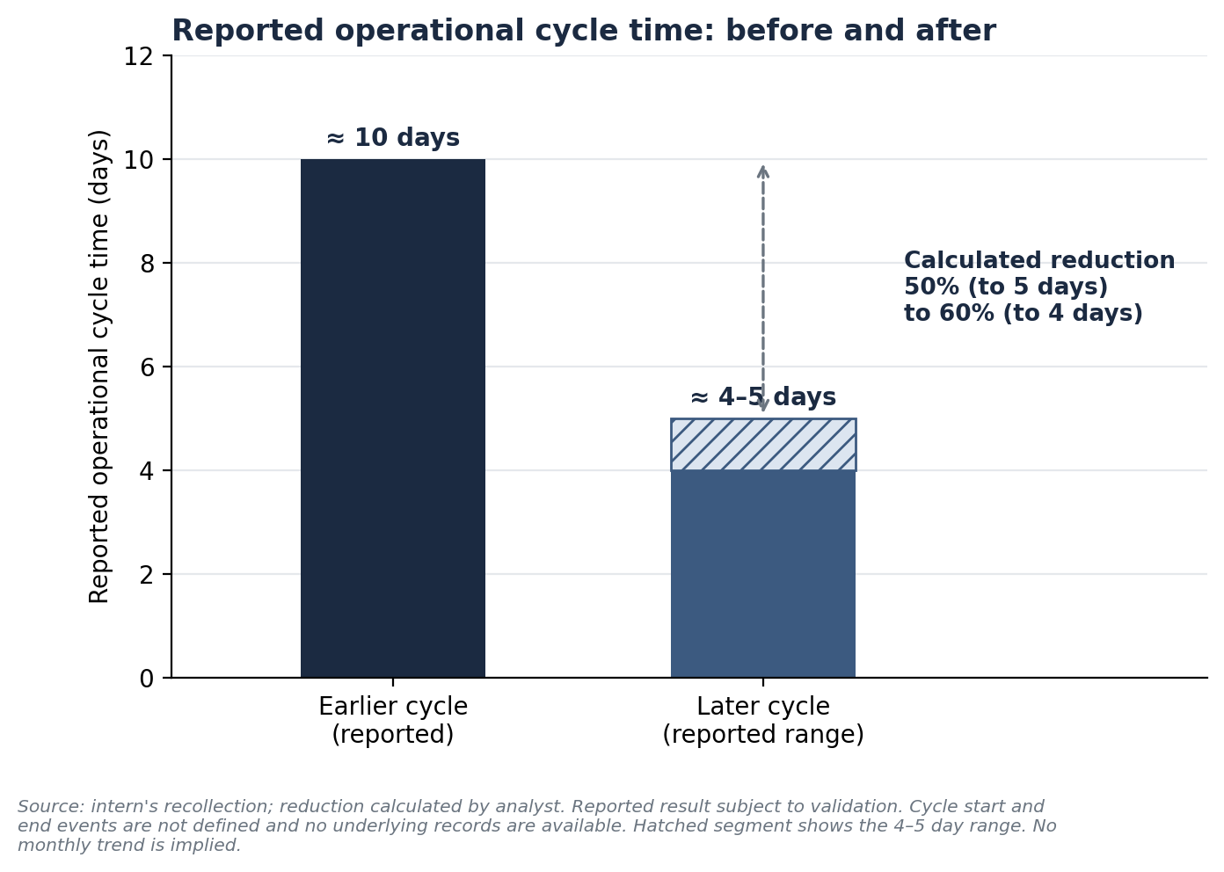
Better coordination, shipment visibility and more structured follow-up may have contributed to faster execution. The dashboard alone is not claimed to have caused the whole reduction. This outcome is distinct from the shipment data accuracy KPI.

13 KPI Framework and Performance Measurement
Figure 5. Operational performance dashboard (template view)
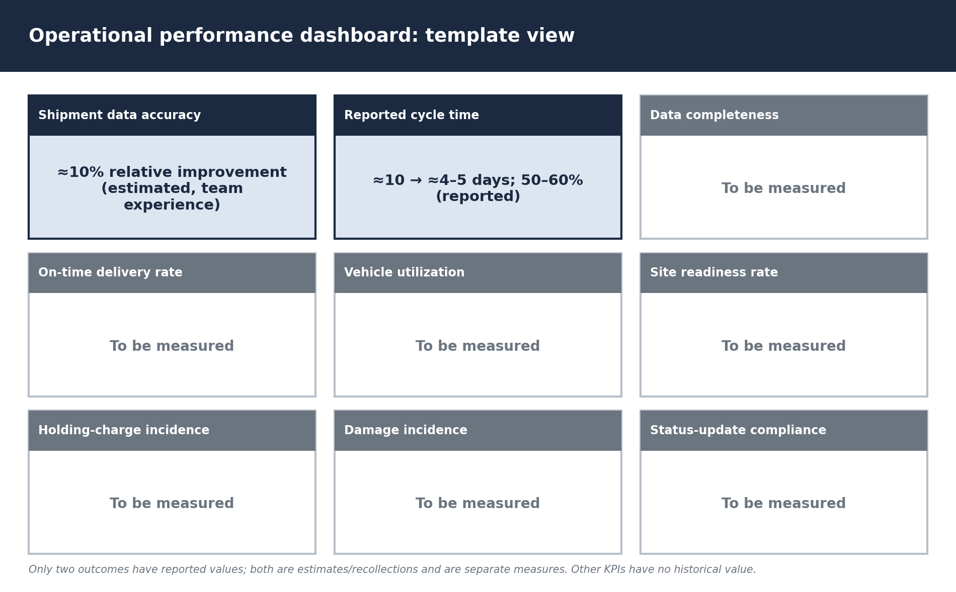
KPI | Formula | Data source | Review
Shipment data accuracy | Accurate records ÷ records audited | Tracker vs source evidence | Monthly audit
Shipment data completeness | Records with all mandatory fields ÷ records reviewed | Tracker | Daily / weekly
On-time delivery rate | Delivered by committed date ÷ consignments due | Required and actual dates | Weekly
Vehicle utilization | Actual utilised capacity ÷ available capacity | Verified capacity and load | Weekly
Site readiness rate | Confirmed ready before dispatch ÷ deliveries assessed | Readiness fields | Daily
Holding-charge incidence | Consignments with holding charges ÷ consignments delivered | Tracker with finance records | Monthly
Damage incidence | Consignments with damage ÷ consignments delivered | Tracker; condition records | Monthly
Status-update compliance | Updated within defined window ÷ shipments requiring updates | Update timestamps | Daily / weekly
The estimated ≈10% data-accuracy improvement is the principal quantified outcome. Other KPIs have no established historical values and should be measured going forward.

14 Recommended Future-State Operating Model
Figure 6. Ten-step future-state workflow
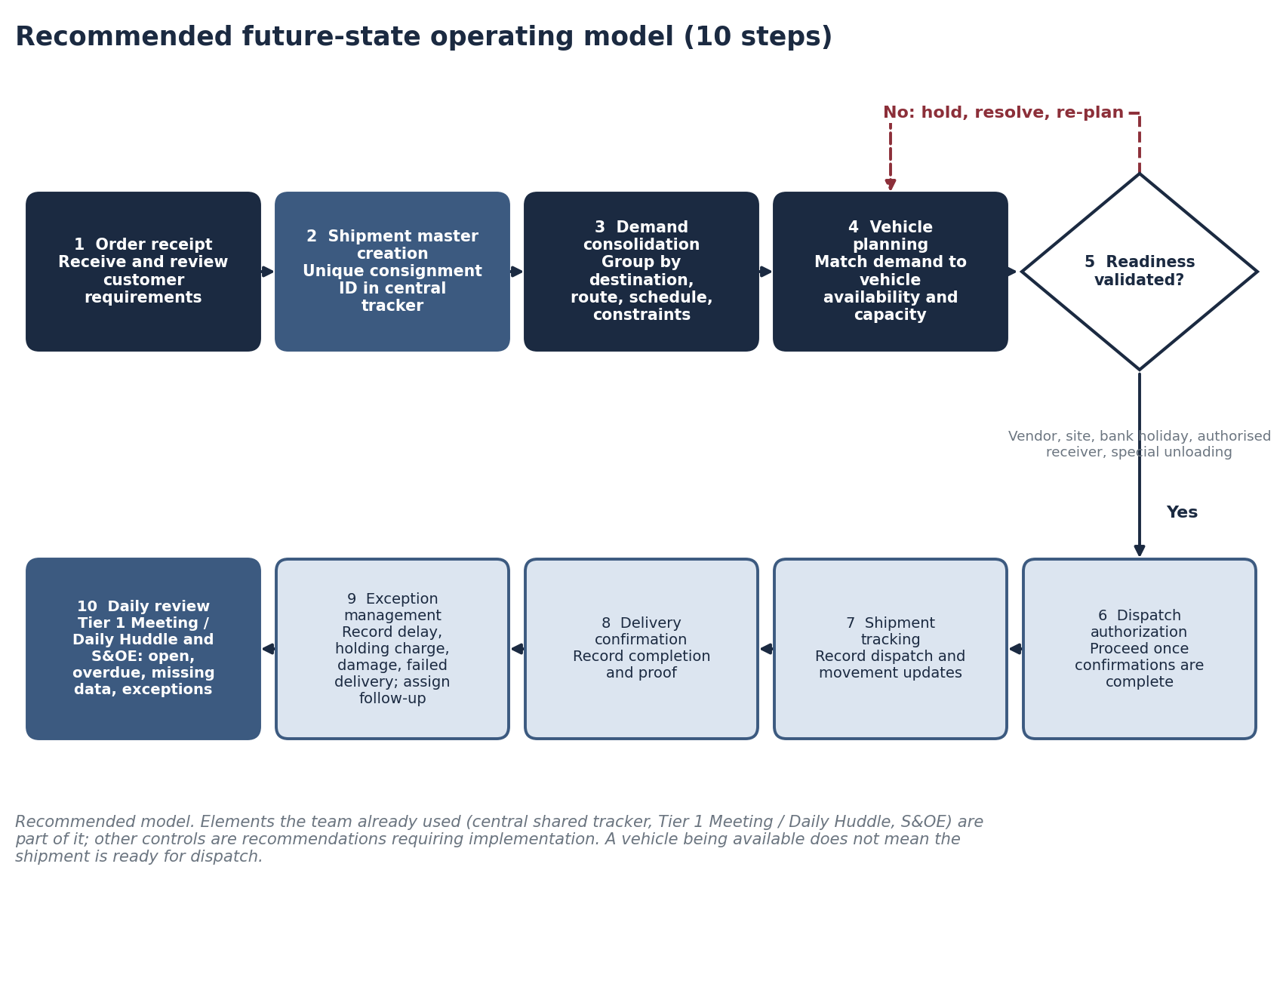
Source: analyst recommendation.
Step | Action
1 Order receipt | Receive and review customer requirements
2 Shipment master creation | Create or update central record with unique consignment ID
3 Demand consolidation | Group compatible shipments by destination, route, schedule and constraints
4 Vehicle planning | Match demand with vehicle availability and suitable capacity
5 Readiness validation | Confirm vendor, site, bank holidays, authorised receiver, special unloading
6 Dispatch authorization | Proceed after confirmations are complete
7 Shipment tracking | Record dispatch and movement updates
8 Delivery confirmation | Record completion and proof
9 Exception management | Record delays, holding charges, damage, failed deliveries; assign follow-up
10 Daily review | Review open, overdue, missing-data and unresolved items in Tier 1 / S&OE
Figure 7. Exception-management workflow
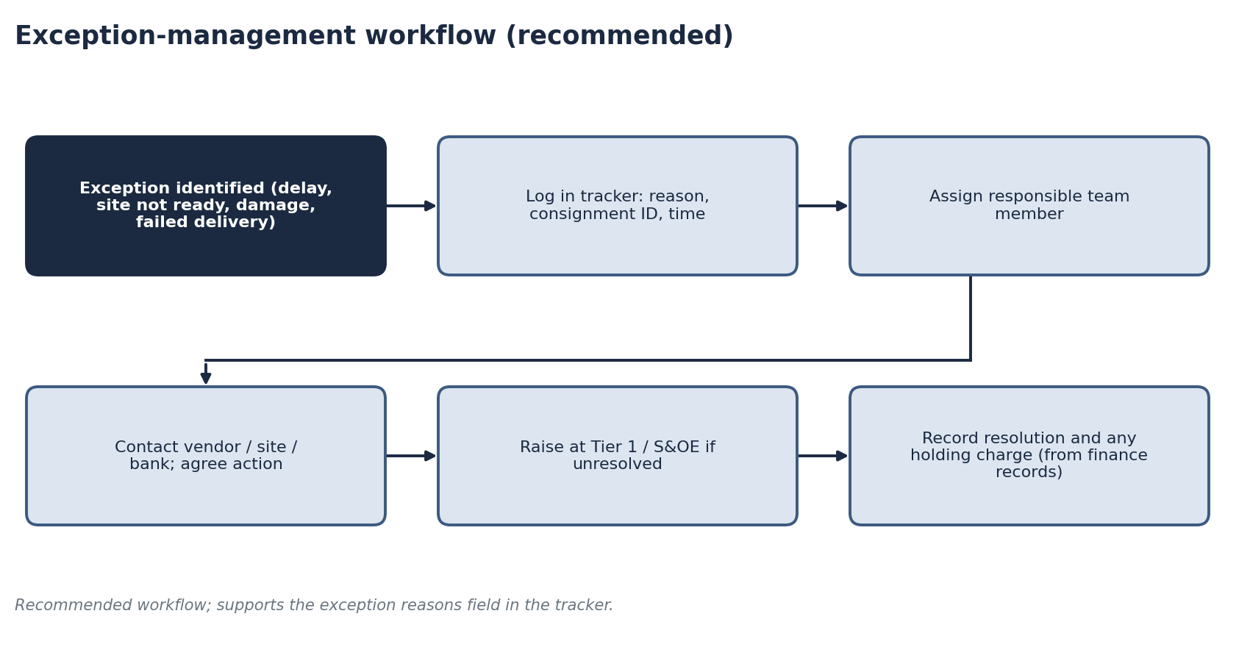
Source: analyst recommendation.

Responsibility matrix (RACI, proposed)
Activity | Team lead | Coordinators / interns | Vendor coordination | Management
Create shipment master and ID | A | R | I | I
Demand consolidation and vehicle plan | A | R | C | I
Readiness validation | A | R | R | I
Dispatch authorization | A/R | C | C | I
Tracker updates | A | R | R | I
Exception follow-up | A | R | R | C
Data-quality checks | A | R | C | I
Daily Tier 1 / S&OE review | A/R | R | C | I
R = Responsible, A = Accountable, C = Consulted, I = Informed. Proposed roles, not confirmed assignments.

15 Financial and Commercial Implications
Better planning, allocation, visibility and readiness checks can influence cost in several ways. No saving is assigned to the Excel dashboard, and no cost reduction is claimed as measured.
Cost driver | How planning and visibility can influence it
Inefficient vehicle utilisation | Compatible-order consolidation fills vehicles better
Separate trips where consolidation is feasible | Seeing orders together reveals combinable movements
Vehicle waiting and holding charges | Readiness checks reduce waiting at unready sites
Repeated coordination and follow-up | A shared record reduces status chasing
Avoidable delivery attempts | Holiday and receiver checks avoid failed attempts
Unplanned special unloading | Capturing needs at intake allows advance arrangements
Delays between stages | Shared visibility reduces hand-over gaps

Financial-impact framework (to be completed with actual data)
Measure | Formula | Data needed
Vehicle utilization (%) | Actual utilised capacity ÷ available vehicle capacity × 100 | Verified capacity and loads
Holding-charge cost | Chargeable holding events × average charge per event | Finance records of events and charges
Avoidable holding-cost reduction (%) | (Baseline holding cost − current holding cost) ÷ baseline holding cost × 100 | Baseline and current period charges
Cost per consignment | Total attributable transportation and handling cost ÷ consignments handled | Invoices; consignment counts
Potential financial benefits are kept separate from the quantified data-quality outcome. No monetary values are supplied here.

16 Implementation Roadmap
Figure 8. Prioritised implementation roadmap
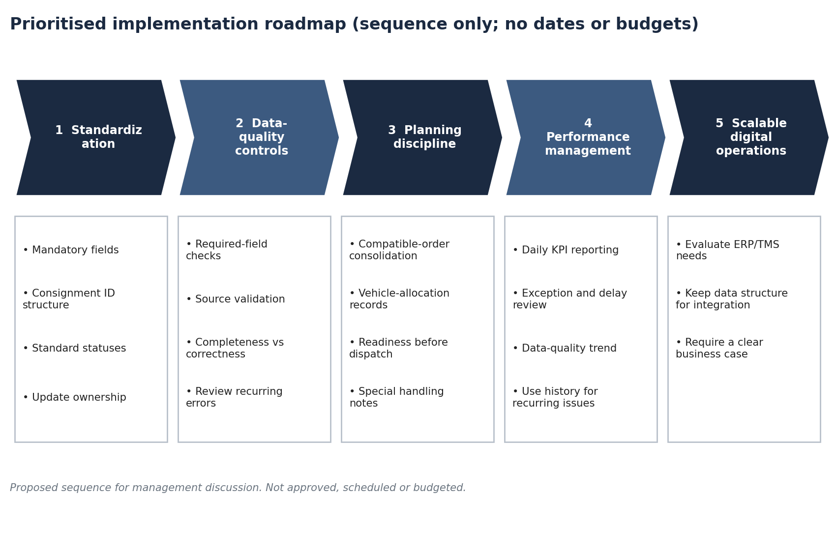
Sequence only; no dates, budgets or approvals implied.
Phase | Objective | Key actions | Owner (proposed) | Success measure | Expected benefit
1 Standardization | Common record structure | Finalise mandatory fields; ID structure; statuses; update ownership | Team lead | Fields and IDs agreed | Consistent records
2 Data-quality controls | Reliable data | Required-field checks; source validation; track completeness and correctness; review recurring errors | Team lead; coordinators | Completeness and accuracy measured | Fewer missing or wrong entries
3 Planning discipline | Better allocation | Formalise consolidation; vehicle-allocation records; readiness before dispatch; special handling notes | Planning coordinators | Readiness rate tracked | Fewer avoidable holds
4 Performance management | Evidence-based review | Daily KPI reporting; exception review; data-quality trend; use history for recurring issues | Team lead; management | KPIs reviewed regularly | Visible performance
5 Scalable digital operations | Prepare for growth | Evaluate ERP/TMS needs; keep data structure for integration; require a clear business case | Management | Documented requirements | Informed technology decision

17 Risks, Limitations and Management Considerations
Risk | Control | Preliminary impact
Records not updated promptly | Named owner; update timestamp; compliance KPI | High
Chat information not entered in tracker | Same-day entry rule | High
Inconsistent entries across users | Dropdowns; required fields; ID standard | Medium
Uncontrolled edits or access | Permissions; periodic checks | Medium
Over-reliance on Excel as volume grows | Review ERP/TMS need with business case | Medium
Metrics not measurable | Define KPIs; capture timestamps | Medium
Impact ratings are preliminary qualitative judgements.
Limitations. The accuracy improvement is an estimate from team experience with no formal audit; the cycle-time boundaries are undefined; vehicle capacities, holding-charge amounts, incident counts and damage rates are unavailable; and no financial benefit is measured.

18 Key Findings and Conclusion
The project showed that daily execution depends as much on information quality as on vehicle supply. Centralising shipment records in a shared tracker gave the team a common reference, made missing information easier to spot and supported the daily Tier 1 and S&OE reviews. Team experience indicates an estimated 10% relative improvement in shipment data accuracy, and the operational cycle was reported to fall by 50–60%, though neither result is formally audited and the dashboard is not claimed as the sole cause of the cycle-time change.
What the team learned: readiness is a separate condition from vehicle availability; consolidation must be balanced against deadlines; and a simple shared record only works with clear ownership and standards. Standard fields, readiness gates, an exception process and KPI measurement can strengthen future operations, and a future ERP or TMS decision can build on the same data structure.

19 Appendices

Appendix A KPI definitions
KPI | Definition and formula | Relevance
Shipment data accuracy | Accurate records ÷ records audited × 100; accurate = complete and verified correct | Reliability of operational information
Shipment data completeness | Records with all mandatory fields ÷ records reviewed × 100 | Visibility of missing information
On-time delivery rate | Delivered by committed date ÷ due × 100 | Delivery performance
Vehicle utilization | Actual utilised capacity ÷ available capacity × 100 | Transportation efficiency
Site readiness rate | Confirmed ready before dispatch ÷ assessed × 100 | Prevents avoidable delays
Holding-charge incidence | Consignments with holding charges ÷ delivered × 100 | Avoidable waiting
Damage incidence | Consignments with damage ÷ delivered × 100 | Handling performance
Status-update compliance | Updated within window ÷ requiring updates × 100 | Tracking discipline

Appendix B Sample shipment tracker (illustrative layout)
Consignment ID | Stage | Quantity | Vendor | Status | Site ready | Receiver | Exception
SAMPLE-001 | Secondary | 2 | Sample vendor 1 | Dispatched | Yes | Yes | None
SAMPLE-002 | Last-mile | 1 | Sample vendor 2 | On hold | No | Pending | Site not ready
SAMPLE-003 | Secondary | 2 | Sample vendor 1 | Planned | Pending | Pending | None
Fictitious sample entries to show layout only. They are not real consignments and are not linked to workbook calculations.

Appendix C Supporting calculations
Item | Calculation | Result
Monthly consignments | 150 × 26 | 3,900
Accuracy before (illustrative) | 900 ÷ 1,000 | 90%
Accuracy after (illustrative) | 990 ÷ 1,000 | 99%
Absolute change | 99% − 90% | 9 percentage points
Relative improvement | (99 − 90) ÷ 90 | 10%
Cycle reduction (to 5 days) | (10 − 5) ÷ 10 | 50%
Cycle reduction (to 4 days) | (10 − 4) ÷ 10 | 60%
Source of numbers: team-reported estimates (≈10% accuracy improvement; ≈10 → 4–5 days; ≈150+ daily consignments), the illustrative 1,000-record example, and analyst calculations.

